



Project Report for Smart ATM Booth

Team : Technovision

Members :Tanumoy Das(704976);Manas Paul(704968);Subhadeep Goswami(704781)

Company : Cognizant

## **1.      Submission name :**Smart Atm Booth

**2.      Short description :**       To build a smart ATM solution leveraging the power of IoT with IBM   
 cloud.

## **3.      Submission track  :**     Climate Change

## **4.      Long description:**

The objective of this prototype is to build an efficient ATM network solution leveraging the power of Internet of Things (IoT) with the help of IBM cloud technology.

Currently, we have a large network of around **236199+ ATMs** only in India. Generally, a conventional ATM requires around **2,500 watts of power per day** (that is, about 700 watts for the ATM and another 1,800 watts for the air conditioners).

We all have noticed the unnecessary use of electricity inside ATM booth, even during when there is no one inside (e.g.: Midnight time & non busy hours). Also we all feel a huge gap in ATM surveillance, in terms of power consumption & security monitoring, in real time approach.

Our solution will address these burning problems & try to reduce the carbon footprint eventually, to build a sustainable future.

Key areas of consideration:

-          Reduce carbon footprint by effectively use the electrical equipment.

-          Reduce electricity bill & unnecessary operational expenditure of banks.

-          Realtime ATM Booth health monitoring.

-          Realtime trigger to concerned authorities in case of potential risk.

## **4.1.           Solution in brief**

We would be using ultrasonic sensor and PIR motion sensor to detect the presence of human being in the ATM Booth and at thus would light the booth and monitor the air-condition accordingly.The ultrasonic sensor can also help in detecting the incoming user of ATM and thus can be used to operate the door of the ATM booth automatically without any physical touch, which would also standout as a precautionary measure in this Covid-19 global pandemic.

We can control and monitor the air- condition and lights remotely with the help of smart technology.

All the output data from the sensor would be displayed in the dashboard for monitoring and the data would be stored in IBM Cloudant, which would be used for future analytics and machine learning purpose.

**4.2.        Technical Functionality**

The objective of our solution is to reduce electric consumption & carbon footprints to save our environment. We’ve incorporated few sensors to drive the overall ATM ecosystem.

* The ultrasonic sensor will sense the presence of any person in a prescribed distance from ATM gate & the output of this sensor will help us to determine the human queue of that time. This output will also help us to take the decision, whether the ATM gate to be opened or not.
* The Motion control sensor will sense the availability of human inside the ATM booth. The output of this sensor along with the help of luminosity sensor will help us to determine the luminosity inside the ATM Booth. If there is a presence, the intensity of the led bulb will be increased , if the lux captured by the luminosity sensor is less and vice-versa so as to maintain the adequate luminosity inside the booth and again it will check the  motion sensor output, to determine still we have any human presence inside ATM or not, if not then the intensity of the light would be switched to dimmed state. It would always go to dimmable state after sometime, if the booth goes in idle condition.
* The Temperature sensor will sense the temp. Inside ATM booth & send the live statistics to server, to monitor the inside temperature real-time.
* All the sensor data to be sent to centralised cloud database & monitored on real time basis, with the help of interactive dashboard.

With these above technical arrangements, we can save a considerable amount of electricity consumed by ATM, throughout the nation & thus, globally in future.

## **4.3.      Solution prospects**

•         Huge energy savings, reduced cost.

•         Energy savings

•         Lowered cost

•         Increased uptime

•         Cleaner environment

•         Easy acceptance, widespread adoption

# **4.4. The Architecture**

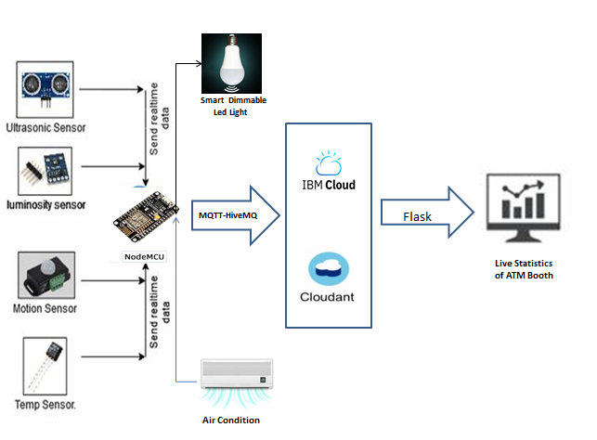

Fig: Technical Architecture

 This above architecture will bring the significant change in whole ATM ecosystem by optimizing the overall resource utilization.

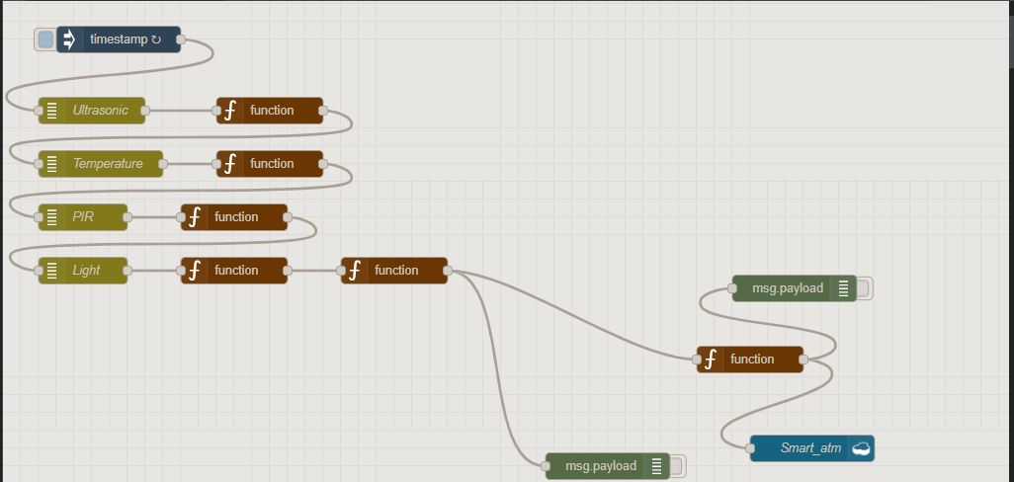

Fig: Simulation flow in Node-RED (IBM Cloud Service)

In this above flow diagram, we have simulated the entire architecture of our smart ATM solution. Based on the output value of the used sensors, entire ATM booth functionality will operate. This real-time sensor value will be directly fed to our real-time dashboard for further analysis purpose.

Any security official can also use the real-time data to monitor the health of that particular ATM booth & take necessary actions as needed.

Also, with the large dataset from the sensor output, a Data Analyst can gain some meaningful insights about any ATM booth.

These above arrangements will help us to build more efficient ATM ecosystem for future.

# **5.    Solution roadmap**

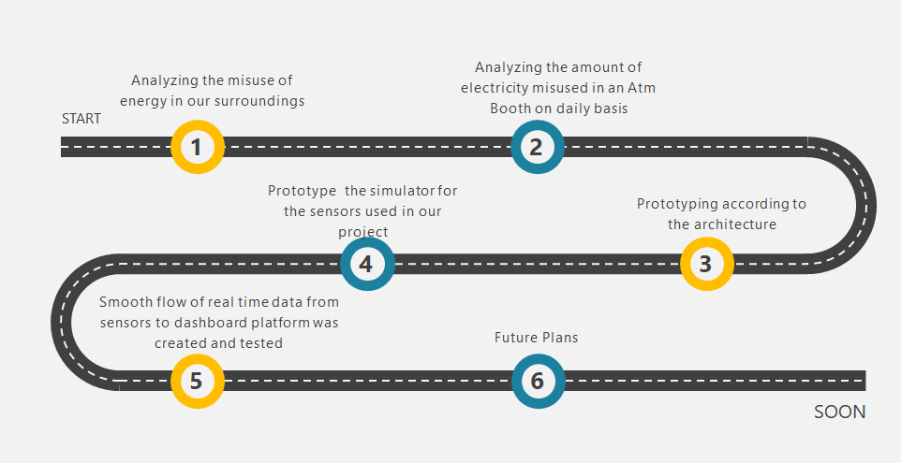

# **6.    Link to publicly accessible GitHub repository**

<https://github.com/tataitanumoy/Smart_Atm_Booth.git>

# **7.    Link to a three-minute demo video**

<https://www.youtube.com/watch?v=wF9ivqgvYy4&feature=youtu.be>

# **8.    List of one or more IBM Cloud Services or IBM Systems used in the solution**

•     Node Red – a service of IBM Cloud.

•         Ibm Cloudant

•         Dashboard using Flask

# **9.    Contact details of Team members**

|  |  |  |  |  |
| --- | --- | --- | --- | --- |
| **#** | **Candidate Name** | **Cognizant Mail ID** | **Designation** | **Mobile No** |
| **1** | Tanumoy Das | [Tanumoy.das3@cognizant.com](mailto:Tanumoy.das3@cognizant.com) | Team Captain | +91-9635060747 |
| **2** | Manas Paul | [Manas.paul@cognizant.com](mailto:Manas.paul@cognizant.com) | Team member | +91-8876033538 |
| **3** | Subhadeep Goswami | [Subhadeep.goswami@cognizant.com](mailto:Subhadeep.goswami@cognizant.com) | Team member | +91-894919211 |